**Ros Version:**

melodic

**Useful Links:**

* Ros Official Pages

1. <http://wiki.ros.org/Robots/Husky>
2. <http://wiki.ros.org/husky_ur5_moveit_config/Tutorials/Husky%20UR5%20Mobile%20Manipulation%20Demo>
3. <http://wiki.ros.org/action/show/universal_robots?action=show&redirect=universal_robot>
4. <https://answers.ros.org/question/318564/spawning-husky-robot-with-ur5/>

* Github links:

1. <https://github.com/husky/husky_manipulation>
2. <https://github.com/ros-industrial/universal_robot/tree/melodic-devel-staging>

**Reasons for Failure:**

Firstly, I followed the Ros official tutorial(See link 1), this tutorial is designed for husky & ur5 integration in indigo version. I thought it might work in melodic, however, it does not provide the API, maybe I should say **input argument** in other words.

Melodic:

<https://github.com/husky/husky/blob/melodic-devel/husky_gazebo/launch/spawn_husky.launch>

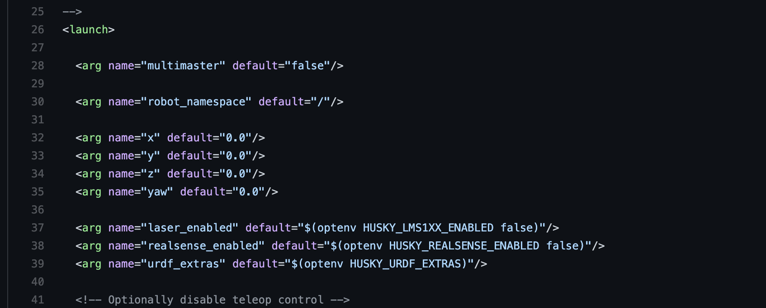

Indigo:

<https://github.com/husky/husky_simulator/blob/indigo-devel/husky_gazebo/launch/spawn_husky.launch>

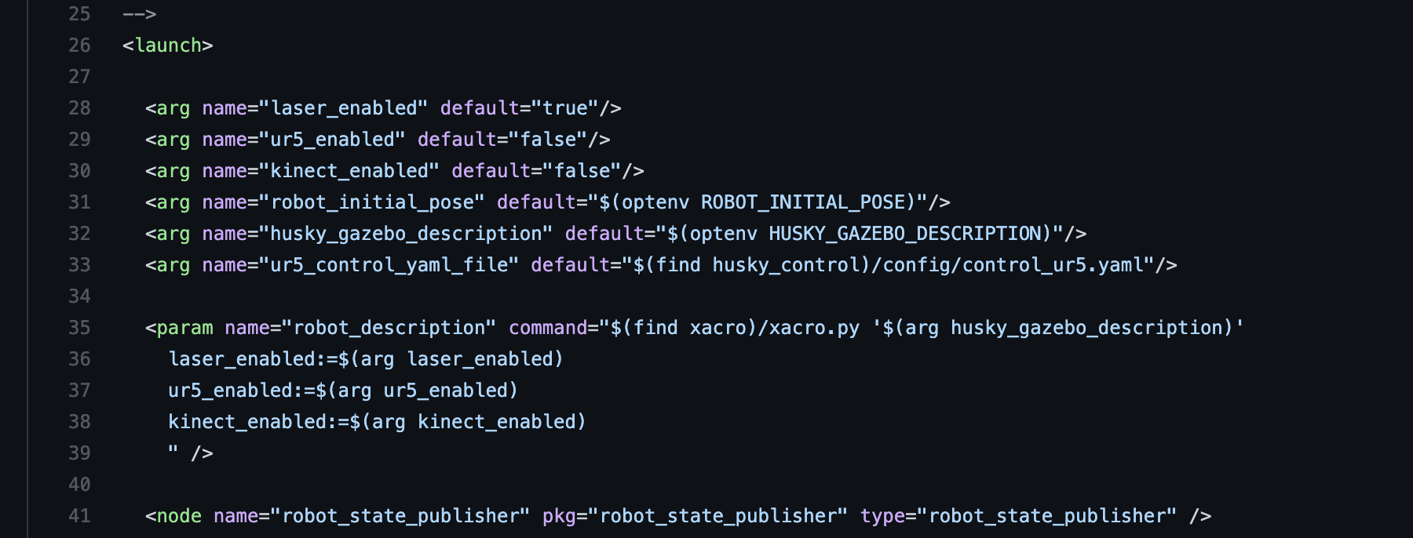

Then I tried to modify input arguments but it will show a lot of missing dependencies in the melodic version.

For the Husky manipulation link <https://github.com/husky/husky_manipulation>

Firstly we need to be clear on one thing. This article is completely different from the last one. The last one is to show you how to modify the launch file to visualize Husky and Ur5 together in the Gazebo environment. For this article, it shows you how to use the package **MoveIt** to make the pose and trajectory planning for a robot(with urdf format, which has the size and range information), it is not for visualizing your robot. Even though you follow the article to visualize the integration simulation in MoveIt, it still cannot be visualized in Gazebo. But at first, I did not realize it.

This article seems to work well in melodic, to be honest, I suppose that this tutorial might not support the melodic version, even though it has the melodic branch.

One reason is that this readme file is not a step-by-step tutorial, you cannot follow the instructions to get the expected result. It will definitely generate some errors while this step (because there is not file name like this if you follow the steps provided)

source $(catkin_find husky_ur_description)/scripts/husky_ur5_envar.sh

When you fixed all the previous bugs and get into this step, to launch the setup assistant (see below)

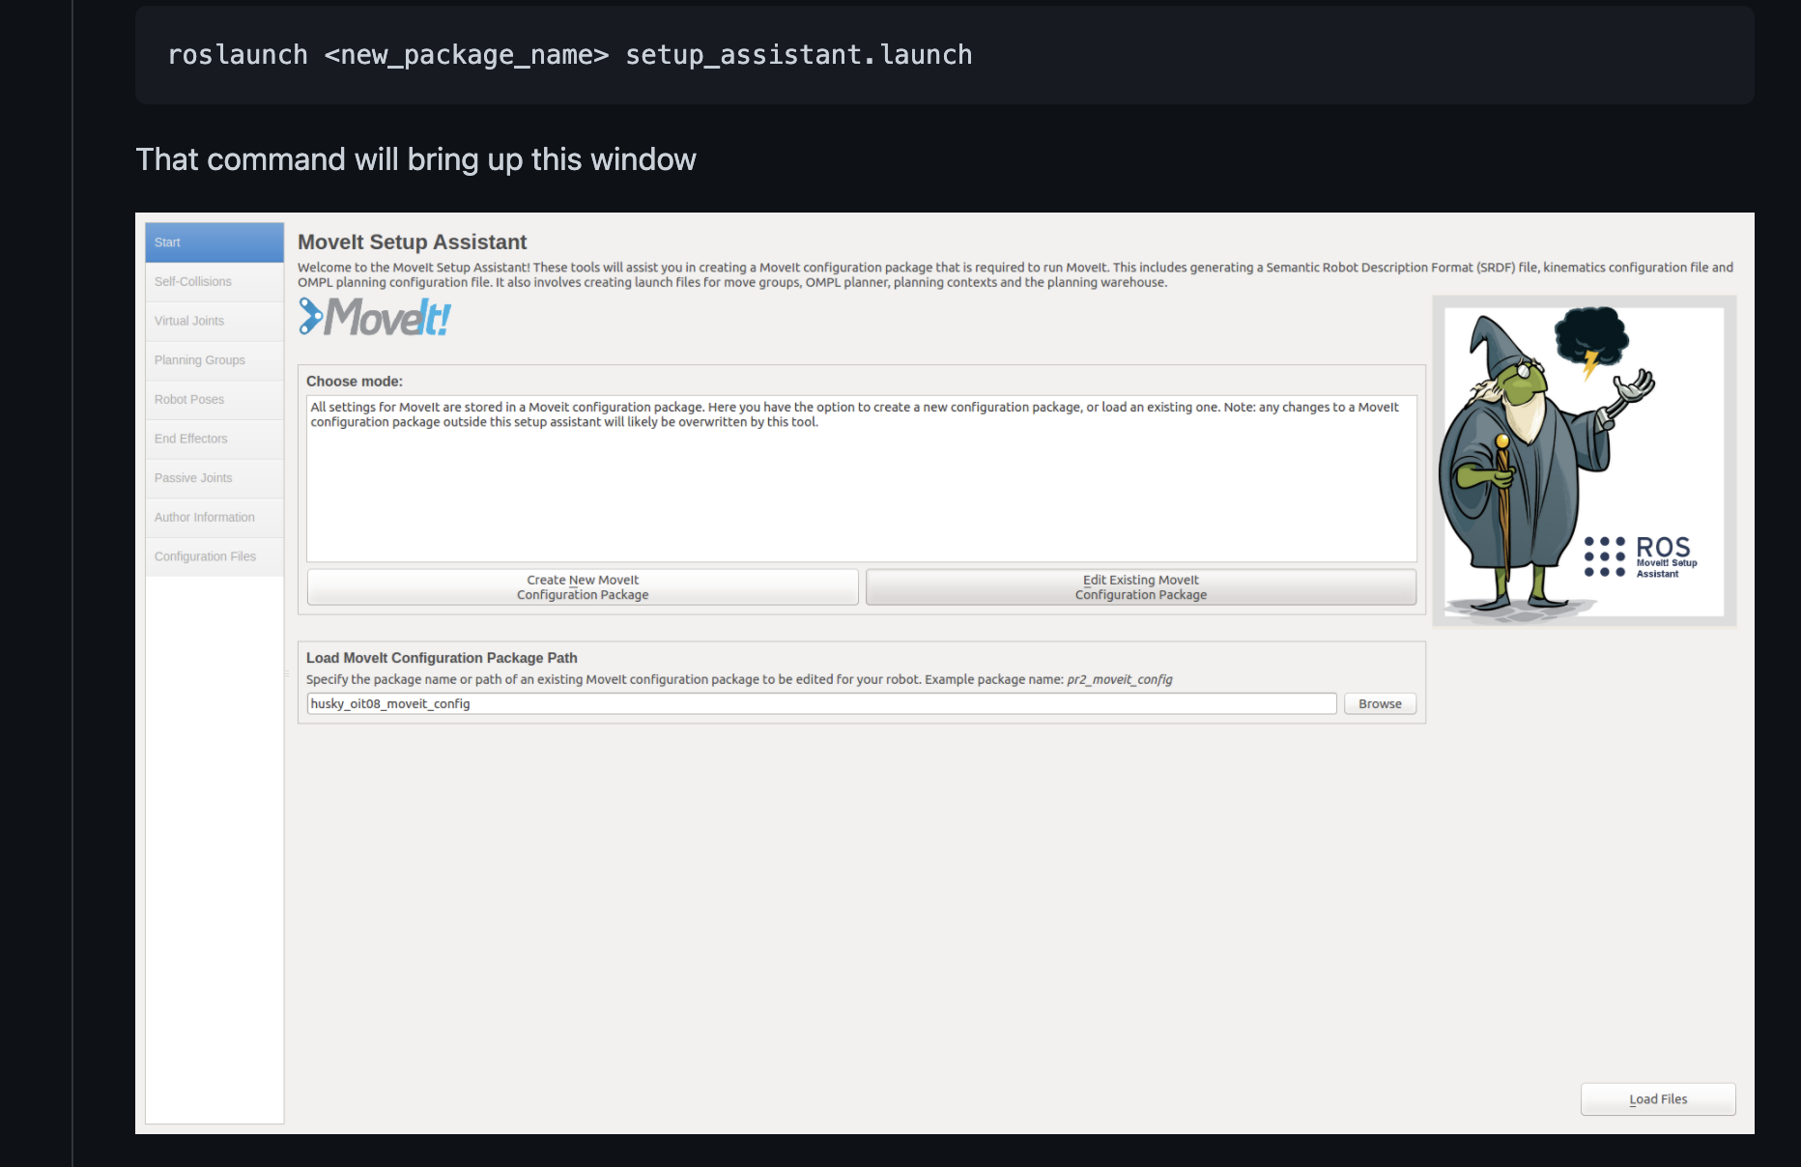

The integrated robot cannot be loaded into the simulation(even though I followed previous steps to integrate URDF files for Husky and UR5 robots), and the assistant UI layout is slightly different (that is why I mentioned the article has nothing different with indigo version, it might just be a cloned branch)

For the setup assistant, it is a tool for you to test if your robot has self-collision or other issues while simulation, but it doesn't make it simulate. For Husky and Ur5, we could load them separately into this tool to test, however, once we got it integrated, this setup tool crashed.

Another case is on this link:

<https://answers.ros.org/question/318564/spawning-husky-robot-with-ur5/>

Someone had the same problem for me for the kinetic version, when I checked the launch file, I noticed that from the kinetic version, the Husky launch file changed(deleted the input argument for loading UR5). And this is the latest case I have found which had the similar problems on integration of Husky and UR5, other posts were in very very old ROS versions.

**Potential Solutions:**

The most useful solution in my mind is to replace the melodic with the indigo version, because it is safe and has official documents and tutorials to support it. I think it probably works. Cons: may have not-compatible packages in the future research and development. For example, maybe the test in indigo version works well, but the gazebo version does not support newly made components, it will bring new problems to us.